Microsoft Windows [版本 10.0.17134.345]

(c) 2018 Microsoft Corporation。保留所有权利。

C:\Users\hp>MySQL -u root -p

Enter password: ******

Welcome to the MySQL monitor. Commands end with ; or \g.

Your MySQL connection id is 24

Server version: 8.0.12 MySQL Community Server - GPL

Copyright (c) 2000, 2018, Oracle and/or its affiliates. All rights reserved.

Oracle is a registered trademark of Oracle Corporation and/or its

affiliates. Other names may be trademarks of their respective

owners.

Type 'help;' or '\h' for help. Type '\c' to clear the current input statement.

mysql> show databases;

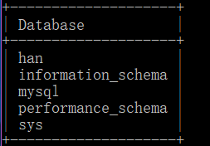

5 rows in set (0.00 sec)

mysql> create database yihan charset=utf8;

Query OK, 1 row affected, 1 warning (0.06 sec)

mysql> show databases;

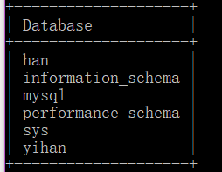

6 rows in set (0.00 sec)

mysql> use yihan;

Database changed

mysql> create table shopping(id int(1) auto_increment primary key,name varchar(2) not null,money varchar(3));

Query OK, 0 rows affected (0.04 sec)

mysql> desc shopping;

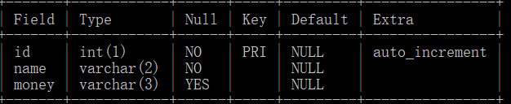

3 rows in set (0.00 sec)

mysql> alter table shopping add xihao varchar(4);

Query OK, 0 rows affected (0.05 sec)

Records: 0 Duplicates: 0 Warnings: 0

mysql> alter table shopping add zhekoutixing varchar(3);

Query OK, 0 rows affected (0.17 sec)

Records: 0 Duplicates: 0 Warnings: 0

mysql> desc shopping;

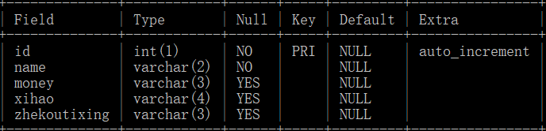

5 rows in set (0.00 sec)

mysql> alter table shopping add shuangshiyiyuanwang varchar(5);

Query OK, 0 rows affected (0.10 sec)

Records: 0 Duplicates: 0 Warnings: 0

mysql> desc shopping;

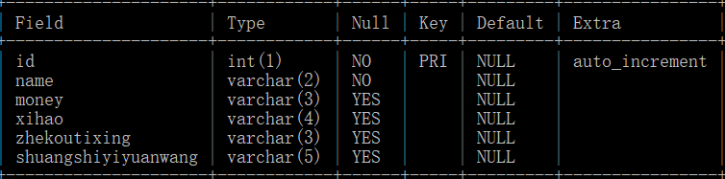

6 rows in set (0.00 sec)

mysql> insert into shopping(

-> id,name,money,xihao,zhekoutixing,shuangshiyiyuanwang)

-> values(1,'hu',200,4,5,2),(2,'xu',100,3,4,5);

Query OK, 2 rows affected (0.02 sec)

Records: 2 Duplicates: 0 Warnings: 0

mysql> desc shopping;

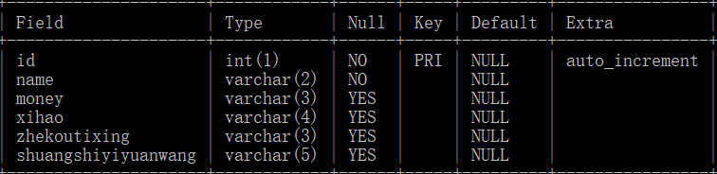

6 rows in set (0.00 sec)

mysql> select * from shopping;

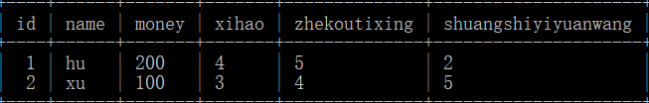

2 rows in set (0.00 sec)

mysql> update shopping set shuangshiyiyuanwang="3" where id=1;

Query OK, 1 row affected (0.10 sec)

Rows matched: 1 Changed: 1 Warnings: 0

mysql> select * from shopping;

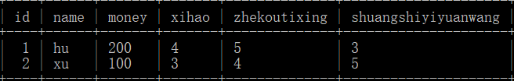

2 rows in set (0.00 sec)

mysql> delete from shopping where id=2;

Query OK, 1 row affected (0.11 sec)

mysql> select * from shopping;

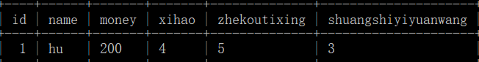

1 row in set (0.00 sec)